
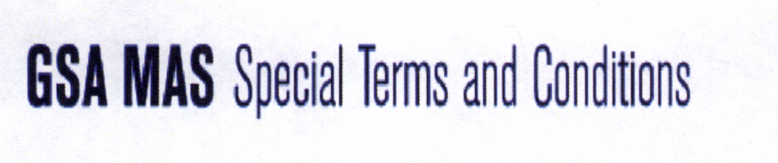

Schedule Title: Multiple Awards Schedule
51 V - Hardware Superstore
FSC 4120 Air Conditioning
Contract Number: GS-06F-0024T
Contract Period: January 27, 2012 to January 23, 2017
Contractor Name: Portable Air Group, LLC
Contractor Address: Portable Air Group, LLC
11415 Governors Drive
Chapel Hill, NC 27517-8420
Contractor Phone: 1-866-948-5300
Fax: 1-866-948-5400
Classification: Small Business
1. SINS
a) Awarded SIN is 639 001 Domestic Appliances.
b) The lowest unit price for item 639 001 PAC163SVT $1,037.00
2. The maximum order under this contract is $$100,000
3. The minimum order under this contract is $1.00
4. Delivery within CONUS, Washington, D.C., AK,
PR, HI.
5. Points of production are listed below*.
6. Prices in this catalog are government net cost
7. There are no quantity discounts.
8. Prompt payment terms are 1% 10 days, net 30
(excludes credit card payments).
9. Portable Air Group, LLC accepts all government
charge cards for purchases of any amount.

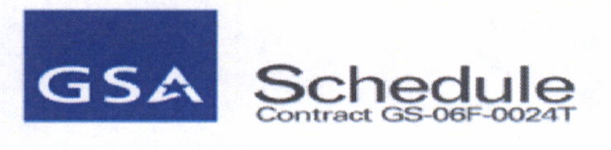

10. KwiKool products are delivered/shipped 2-14 days ARO and Port-A-Cool products are delivered/shipped 2-14 days ARO.
All items, if available, can be handled on expedited delivery or overnight and 2nd day delivery at an additional cost that can be arranged by the contractor. Agencies may also contact the contractor for the arrangement of urgent requirements.
11. FOB Origin for CONUS shipments
12. The ordering address is:
Portable Air Group, LLC
11415 Governors Drive
Chapel Hill, NC 27517-8420
13. The payment address is:
Portable Air Group, LLC
11415 Governors Drive
Chapel Hill, NC 27517-8420
14. All equipment comes with the manufacturer’s standard warranty.
15. Export packing charges are the responsibility of ordering agencies.
16. Government purchase cards are accepted.
17. Agencies may contact contractor for distribution and servicing points.
18. There are no participating dealers in this program.
19. There are no preventative maintenance programs available.
20. a) There are no special environmental attributes to this equipment.
b) Section 508 is not applicable.
21. The DUNS number is 78-416-2070.
22. Portable Air Group, LLC is registered in the CCR (Cage: 4KAJ5) and ORCA database.
23. Uncompensated Overtime is not applicable.
*KwiKool units POP is Houston Texas
*Port-A-Cool POP is Center Texas

